Test report

1. Compute Simulation State method
2. Source code of ComputeSimulationState.java with code coverage,

|  |
| --- |
| C:\Users\Munna\Desktop\Photos\ComputeSimulationCode1.JPG |
| C:\Users\Munna\Desktop\Photos\ComputeSimulationCode2.JPG |
| C:\Users\Munna\Desktop\Photos\ComputeSimulationCode3.JPG |
| C:\Users\Munna\Desktop\Photos\ComputeSimulationCode4.JPG |
| C:\Users\Munna\Desktop\Photos\ComputeSimulationCode5.JPG |
| C:\Users\Munna\Desktop\Photos\ComputeSimulationCode6.JPG |
| C:\Users\Munna\Desktop\Photos\ComputeSimulationCode7.JPG |

1. Coverage report of ComputSimulationState.java,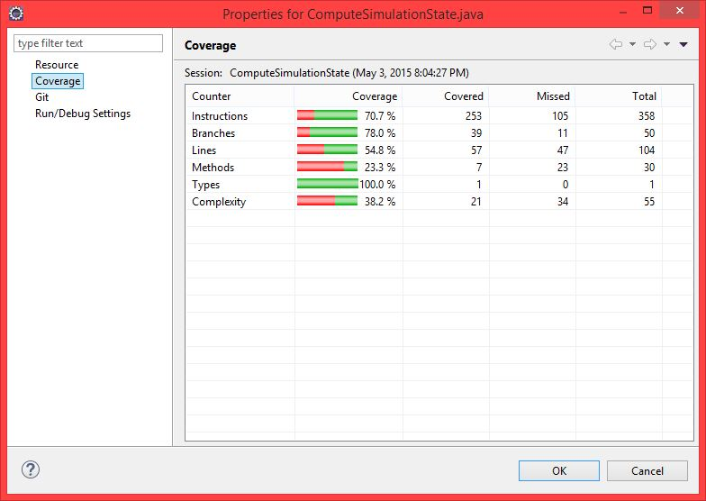
2. Test result as console output as we run the ComputeSimulationState,

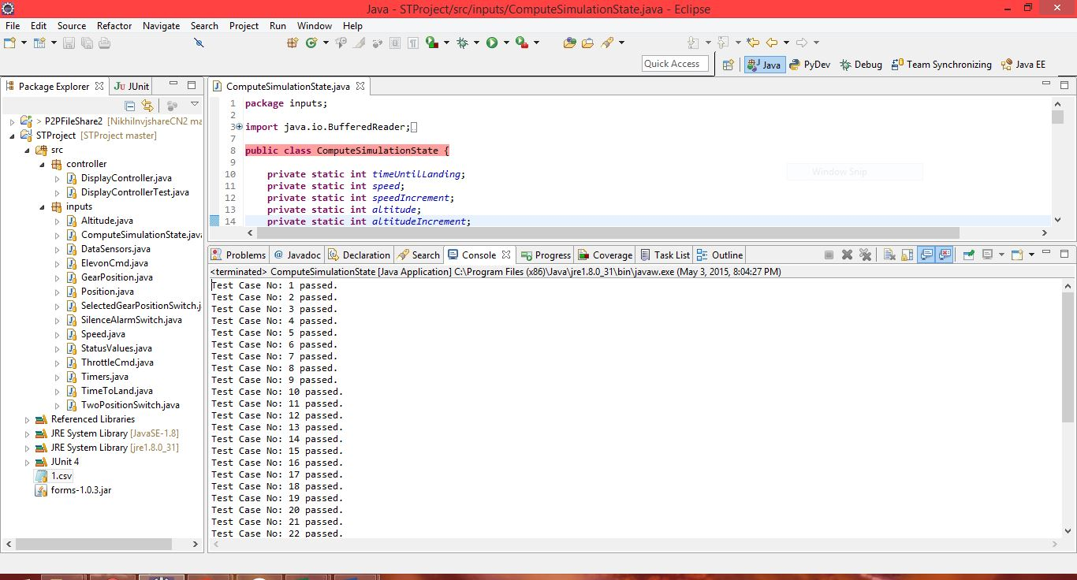

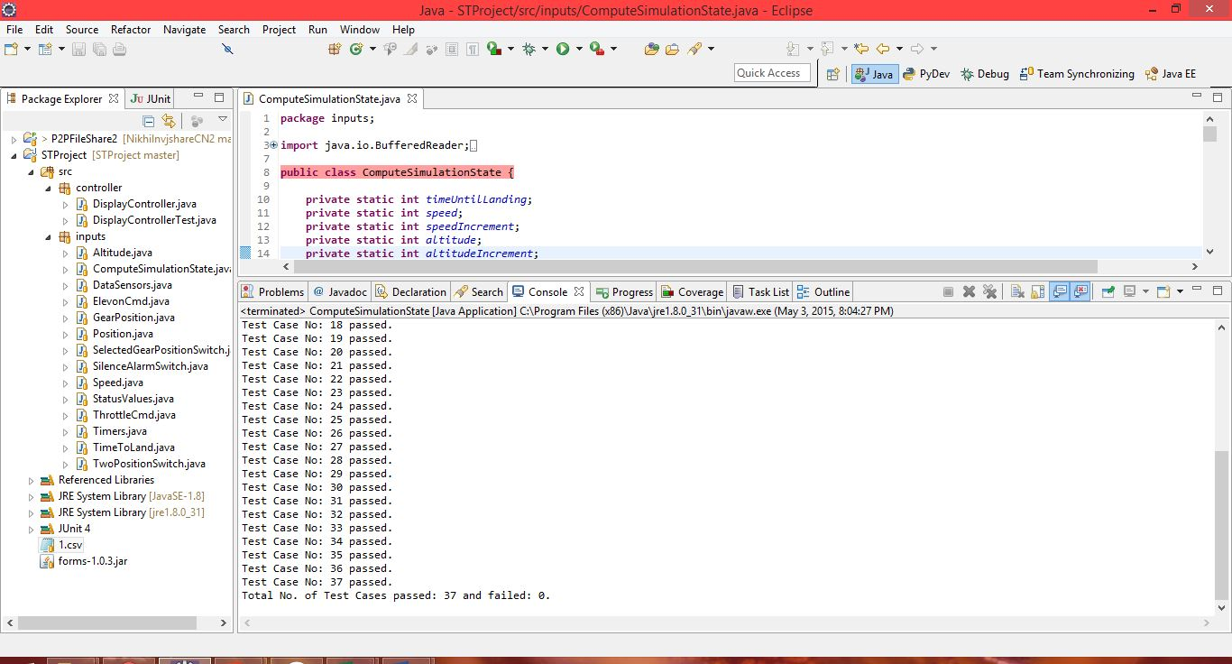

1. Test summary:
2. We are testing the computesimulationstate method taking inputs from csv file and comparing the expected output of the same from it.

Test case Inputs: Speed, Gear Down, Altitude, Time.

Test Case Outputs: Gear Not Down alarm, Gear Air Speed alarm, Air Brake warning, Gear Override warning, Gear-up command, Silence Alarm.



1. In the above file, we have 37 test cases, which were run on computesimulationstate method of computesimulationstate class, which resulted in 100% pass i.e. all 37 test cases passed successfully and 0 failed the same can be seen in above console output.
2. From the coverage properties above, we have overall coverage as 70.7%, wherein 29.3% shortfall can be viewed as the computesimulationstate class also has code which is traversed by DisplayController class to get and set input variables (Getters & Setters) to compute alarms/warnings, such as throttlecmd and elevoncmd are button click events of DisplayController JFrame and exception handling statements are not covered as we have a normal run case.

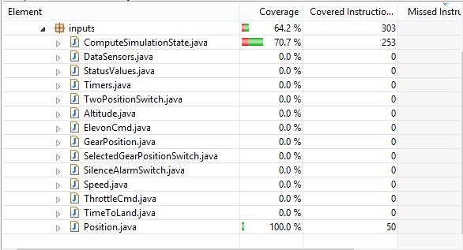

1. No, coding problems as all test cases passed successfully.
2. Here, we can observe that we are testing specific outputs of alarms and warnings but we aren’t checking for conditions such as no alarms and warnings etc, i.e. we are doing positive testing.

1. DisplayController Class JUnit Test Run:

Here, we would comment both the main method of ComputeSimulationState which was used to test 37 test cases above and DisplayController which is used to run real-time simulation of the aircraft as both won`t be traversed in running the Junit test class of DisplayControllerTest.java.

1. Source code of DisplayControllerTest.java with code coverage,

|  |
| --- |
| C:\Users\Munna\Desktop\Snaps\test1.JPG |
| C:\Users\Munna\Desktop\Snaps\test2.JPG |
| C:\Users\Munna\Desktop\Snaps\test3.JPG |

Source code of DisplayController.java with code coverage,

|  |
| --- |
| C:\Users\Munna\Desktop\Snaps\display1.JPG |
| C:\Users\Munna\Desktop\Snaps\display2.JPG |
| C:\Users\Munna\Desktop\Snaps\display3.JPG |
| C:\Users\Munna\Desktop\Snaps\display4.JPG |
| C:\Users\Munna\Desktop\Snaps\display5.JPG |
| C:\Users\Munna\Desktop\Snaps\display6.JPG |
| C:\Users\Munna\Desktop\Snaps\display7.JPG |
| C:\Users\Munna\Desktop\Snaps\display8.JPG |

Source code of ComputeSimulationState.java with code coverage,

|  |
| --- |
| C:\Users\Munna\Desktop\Snaps\ComputeCode1.JPG |
| C:\Users\Munna\Desktop\Snaps\ComputeCode2.JPG |
| C:\Users\Munna\Desktop\Snaps\ComputeCode3.JPG |
| C:\Users\Munna\Desktop\Snaps\ComputeCode4.1.JPG |
| C:\Users\Munna\Desktop\Snaps\ComputeCode4.JPG |
| C:\Users\Munna\Desktop\Snaps\ComputeCode5.JPG |

1. Coverage report of DisplayControllerTest.java,

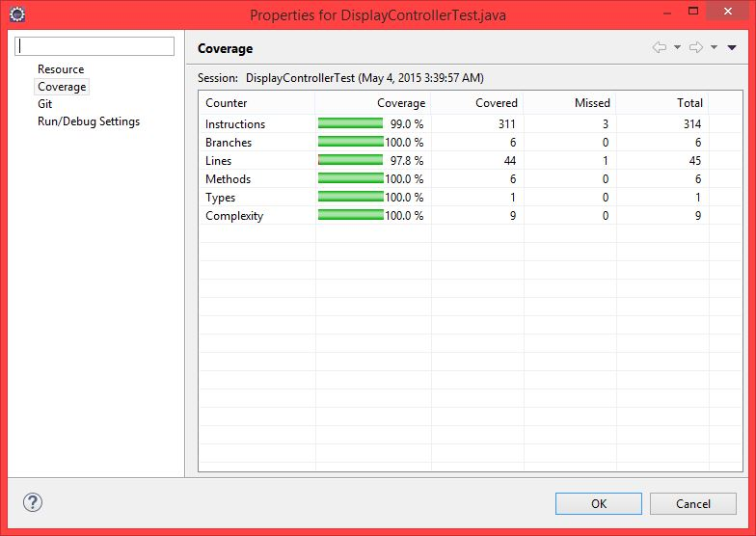

Coverage report of DisplayController.java,

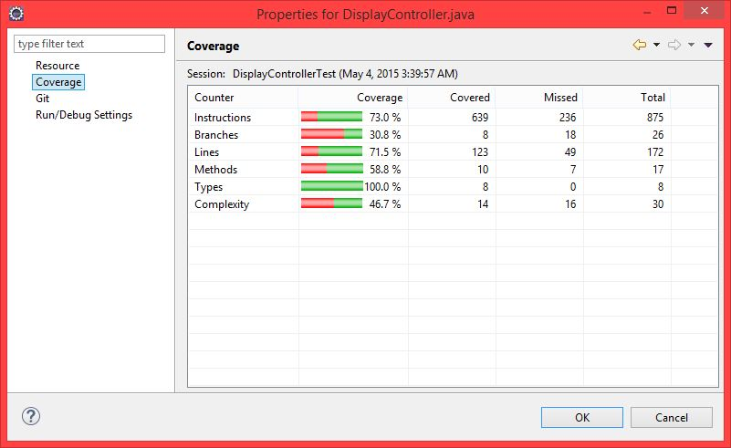

Coverage report of ComputSimulationState.java,

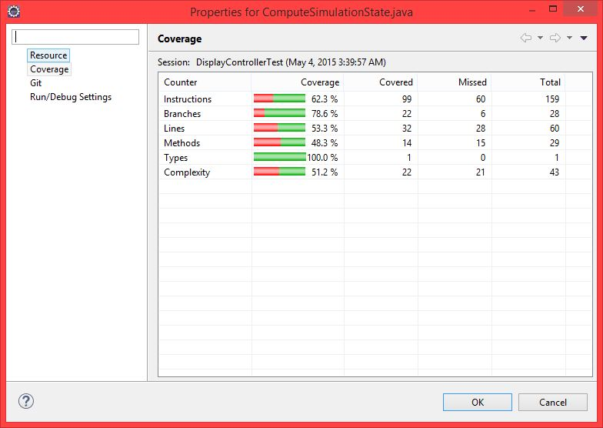

1. JUnit test result successful notification of DisplayControllerTest.java.

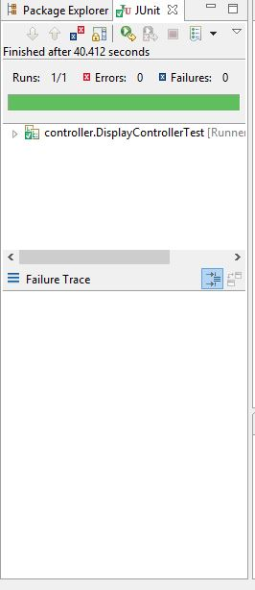

1. Test Summary
2. Here, we are testing 8 Display Scenarios comparing Display Scenarios implemented at the time of PART 2 of project to Display Scenarios generated by code.

Test case Inputs: Speed, Gear Down, Altitude, Time

Test Case Outputs: Gear Not Down alarm, Gear Air Speed alarm, Air Brake warning, Gear Override warning, Gear-up command.

PART 2 Display Scenarios Test Oracle.

|  |  |  |  |  |  |  |  |  |  |
| --- | --- | --- | --- | --- | --- | --- | --- | --- | --- |
| Display Scenario | Speed | Gear Down | Altitude | Time | Gear Not Down alarm | Gear Air Speed alarm | Air Brake warning | Gear Override warning | Gear-up command |
| 1 | 401 | Y | 1000 | 59 |  | X | X | X | X |
| 2 | 401 | N | 1000 | 59 | X |  | X |  |  |
| 3 | 401 | Y | 999 | 121 |  | X |  | X | X |
| 4 | 401 | N | 1000 | 120 | X |  |  |  |  |
| 5 | 401 | N | 1000 | 121 |  |  |  |  |  |
| 6 | 301 | Y | 999 | 59 |  | X | X |  |  |
| 7 | 400 | Y | 999 | 120 |  | X |  |  |  |
| 8 | 300 | Y | 999 | 59 |  |  | X |  |  |

Our PART 2 Display Scenarios Test Oracle: Similar to above with different scenario number.

|  |  |  |  |  |  |  |  |  |  |
| --- | --- | --- | --- | --- | --- | --- | --- | --- | --- |
| Display Scenario | Speed | Gear Down | Altitude | Time | Gear Not Down alarm | Gear Air Speed alarm | Air Brake warning | Gear Override warning | Gear-up command |
| 1 | 249 | N | 1500 | 59 | X |  |  |  |  |
| 2 | 401 | N | 1500 | 59 | X |  | X |  |  |
| 3 | 401 | Y | 1500 | 59 |  | X | X | X | X |
| 4 | 401 | Y | 1500 | 121 |  | X |  | X | X |
| 5 | 301 | Y | 1500 | 59 |  | X | X |  |  |
| 6 | 301 | Y | 1500 | 121 |  | X |  |  |  |
| 7 | 250 | Y | 1500 | 59 |  |  | X |  |  |
| 8 | 415 | N | 1025 | 130 |  |  |  |  |  |

1. Test Results

|  |  |
| --- | --- |
| PART 2 Outputs | Program Output |
| C:\Users\Munna\Desktop\Snaps\dsx1.JPG | C:\Users\Munna\Desktop\Snaps\dsnew1.JPG |
| C:\Users\Munna\Desktop\Snaps\dsx2.JPG | C:\Users\Munna\Desktop\Snaps\dsnew2.JPG |
| C:\Users\Munna\Desktop\Snaps\dsx3.JPG | C:\Users\Munna\Desktop\Snaps\dsnew3.JPG |
| C:\Users\Munna\Desktop\Snaps\dsx4.JPG | C:\Users\Munna\Desktop\Snaps\dsnew4.JPG |
| C:\Users\Munna\Desktop\Snaps\dsx5.JPG | C:\Users\Munna\Desktop\Snaps\dsnew5.JPG |
| C:\Users\Munna\Desktop\Snaps\dsx6.JPG | C:\Users\Munna\Desktop\Snaps\dsnew6.JPG |
| C:\Users\Munna\Desktop\Snaps\dsx7.JPG | C:\Users\Munna\Desktop\Snaps\dsnew7.JPG |
| C:\Users\Munna\Desktop\Snaps\dsx8.JPG | C:\Users\Munna\Desktop\Snaps\dsnew8.JPG |

1. In our code, we are running all 8 display scenarios with a time lag of 10sec in a single run. We have all display scenarios matched with Test oracle. 100%Pass and 0% failed.
2. We have 73% overall coverage, with 28% shortfall, as in DisplayController class button action aren’t performed while considering the 8 display scenarios so the code is not covered and in ComputeSimulationState class also button action and getters and setters of all variables isn’t traversed.

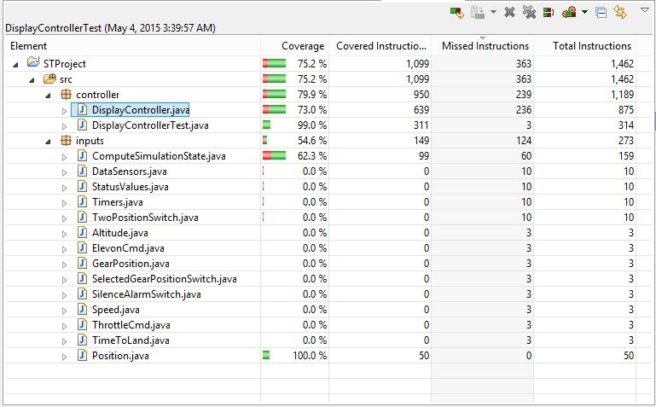

1. We have a coding problem, In Scenario 3, 4 we have Landing Gear Override warning ON which results in automatic landing gear position to “up”, as it is down. Here, in code the same is implemented in main method which we aren’t testing. Therefore, the change in gear position from down to up isn’t shown in display scenarios above.
2. None
3. Other items of discussion:
4. We have implemented full working landing simulation of aircraft which shows different alarms/warnings and performs actions if any. It also checks for proper landing at TimetoLanding = 0, speed =0 & altitude = 0 and displays “Landed” else shows failed.
5. ….
6. Project learning experience can be improved by…
7. Yes, Project would be useful in future classes as it helped in gaining practical experience w.r.t. Junit and Jacoco which are used in industry.